**My requirement here**: I want to create reusable image

Case study- There is a tool that has business intelligent in it and depending on user input it create reusable image.

Example- Packer.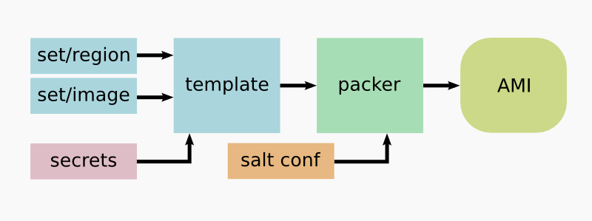

Note- For creating image, we provide JSON file as input to Packer.

Packer has 2 important components-

1. Builder
2. Provisioning.
3. Postprocessing

**Builders**

Builders are responsible for creating machines and generating images from them for various platforms. For example, there are separate builders for EC2, VMware, VirtualBox, etc. Packer comes with many builders by default and can also be extended to add new builders.

**Provisioning:**

It’s a custom work that need to perform, like installing java on box.

**Postprocessing**

Once your work is done, you can change the format also.